HW9 deadline: 2020/05/12

Please find the attached for the Simulink model for the UAV.

Given , *d* =.

*R* is initially aligned with $R_{d}$. $x_{d}=[0 0 2]$.

The homework is to design a geometric controller with **attitude controlled flight mode**.

Hint: ${\dot{R}}_{d}=R_{d}{\hat{Ω}}_{d}$

$e_{R}=\frac{1}{2}{(R_{d}^{T}R-R^{T}R_{d})}^{∨}$

$e_{Ω}=Ω-R^{T}R_{d}Ω_{d}$

1. You need to modify “**controller.m**”
2. There is explanation for every function in “**readme.txt**”
3. 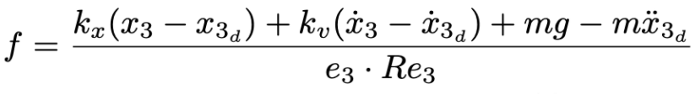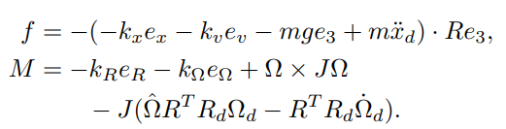Don’t implement this term.
4. You must show $e_{R}$ in **scope** of Simulink.